TITLE, Arial 14, bold, underlined
A. Name presenting¹, B. Name^{1,2}, C. Name², D. Name³, E. Name corresponding^{3,}*

¹Affiliation1, city, country
² Affiliation2, city, country

Email: corresponding@univ-bidule.fr
Enter here your text : Arial 10.5, Interline 1.15. The limit is one page (strictly, your abstract will be cut after one page).

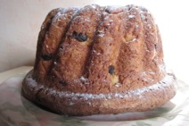
Figure : It is possible to insert figure(s). Please, insert the figures in jpg format to avoid problems of conversion.

Acknowledgements

References
- A. Name1, B. Name2, C. Name3, T, Titre, Journal, 2008, 91, 879-886.
- A. Name1, B. Name2, C. Name3, T, Titre, Journal, 2008, 91, 879-886.

